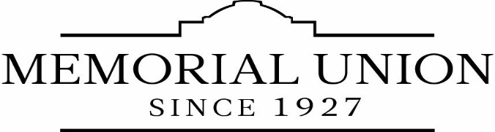

SECTION 1. POSITION INFORMATION
Title  MU Event Staff | c. Effective Date (m/d/y) | X Academic Year
Working Title  Event Staff |  | Work Unit  Memorial Union Guest Services
Name

SECTION 2. PROGRAM/POSITION INFORMATION
a. Describe the program in which this job exists. Include program purpose, size, scope and who is affected.
Include relationship to department mission.

The purpose of the Memorial Union is to provide a center for social, cultural, and recreational programs and services for students, faculty, staff, alumni, and guests of Oregon State University; to provide opportunities for experience in social responsibility and leadership; to supplement University instruction by developing high ideals of university spirit, citizenship, and private life. Virtually every OSU student and many of the faculty, staff, alumni, and guests are affected. The scope of the impact is in direct relationship to the level of participation by each user.

This program is an integral part of the educational experience of OSU students, assists in the retention of students, accommodates university service for faculty and staff, encourages involvement by alumni, and presents a positive image of Oregon State University to guests and visitors.
b. Describe the purpose of this position, and how it functions within this program.

This is an entry level position. The event staff will perform setup and teardown of rooms and train on audio-visual equipment and other operations needed to support successful events. This position works under the supervision of the Setup Coordinators for large or multiple events or Event Managers for small setups.

Clear and respectful communication is essential in creating a nurturing, engaging and sustainable environment.

The purpose of the position is to serve as a member of the Guest Services Event Staff. Guest Services, located in the Memorial Union serves the student, faculty, staff and guests of the University.

Guest Services Event Support is a high profile position. Customers observe and experience staff behaviors and communication styles. Professional behavior means exhibiting a courteous and businesslike manner in the workplace. This behavior is expected at all times when at staff member is in the Memorial Union working or on personal business.

c. SPECIAL REQUIREMENTS:

- Must wear protective safety equipment, including (at a minimum) closed-toed shoes. Department ID badges may be required for some large events.
- Work schedules include nights, weekends and finals week. Fall training occurs two weeks prior to the start of classes.
- Mandatory attendance of staff meetings, trainings, and all shifts.
- Must be able to lift 35 lbs. at a steady pace for an hour.
- Must be detail-oriented.
- Preferred qualifications include a demonstrable commitment to promoting and enhancing diversity.

SECTION 3: LIST OF MAJOR DUTIES

Duties
Setup and Teardown
- Work in teams and individually to set up and tear down rooms and event space.
- Knowledge of setup verbiage and room setup details for different rooms and equipment.
- Working knowledge of basic audio-visual equipment.
- Work collaboratively during setup and teardown with Building Managers, Information Desk, Custodial and Maintenance staffs.
- Maintain neat and clean appearance of office, lounges, meeting rooms, hallways (in coordination with custodial staff).
- Must complete assigned shifts regardless of time scheduled.

Store room
- Organization of furniture storeroom and audio-visual storage rooms.
- Maintain orderly appearance in all storage areas.

Other Duties
- As requested by setup coordinators, event managers or building managers.
- Assist Building Managers, Custodial & Information Desk Staff as needed with their duties.
- Attend required student employee staff development meetings/programs/trainings.
- Provide prompt and courteous customer service to guests and clients.
Who reviews the work of this position? How? How often? Purpose of the review?

Supervisor, setup coordinators, event managers and building managers. Verbally and daily as needed. Reviews are designed to ensure staff excellence and enhance performance.

Employee Signature Date | Supervisor Signature Date

